

The VSP Server

Payment Process in detail

Author: | Mat Peck
Creation Date: | Monday, 30 July 2001
Version: | 1.1
Last Modified: | Friday, 28 June 2002
Modified by: | Mat Peck

Security Rating: Public.
Distribution List: PROTX Staff, Customers and Contacts.

Table of Contents

1: Introduction 1
2: The Step-by-Step Payment Process 1
2.1: Customer selects good/services at the Vendor Website 1
2.2: Vendor Server sends an HTTPS post to VSP Server 2
2.3: VSP Server validates the POST and replies to the Vendor 3
2.4: Vendor redirects the Customer to the VSP 4
2.5: Customer accesses or enters card details on the VSP 4
2.6: The VSP requests Authorisation from the Banks 5
2.7: VSP server contacts the Vendor on the Notification URL 6
2.8: The Vendor replies to the VSP Notification POST 7
2.9: VSP redirects the Customer back to the Vendor site 8
2.10: VSP sends daily Batch file to initiate payments 8
3: The VSP Transaction Monitor 9
4: Other VSP Server Messages 10
4.1:PREAUTH requests 10
4.2: DEFERRED payments 10
4.3: RELEASE deferred payment 11
4.4: REPEAT payments 12
4.5: REPEATDEFERRED payments 13
4.6: REFUND requests 13

1: Introduction

This document explains, in detail, the VSP Server payment process and the interaction between the Vendor website and Protx. The details are for VSP Server only, please refer to other documentation for VSP Form, VSP Direct and VSP Wallet.

NOTE: Original the protx VSP Server product was called the “Verified Payment System” and was referred to by the acronym VPS. When the product expanded to support a variety of interfaces, the name was changed to reflect the type of interface used. When reference is made to VPSTxID or VPSProtocol, these are not spelling errors since these field names date back to the original system. In the main text of the document, VPS and VSP are used interchangeably.

This document is intended for general distribution.

2: The Step-by-Step Payment Process

This section illustrates a typical online payment through the VSP.

2.1: Customer selects good/services at the Vendor Website
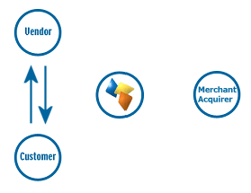
The customer interacts with the Vendor web site in the usual manner, filling a shopping cart with products, or electing to pay for a service of some description.

The Vendor site will calculate the price of the goods, obtain customer details (such as name, delivery address and so on, but NOT credit/debit card details) and present the user with a final confirmation screen, asking if they wish to proceed, and often, informing them that they will be redirected to Protx to complete their payment. The “continue” or “pay” button on this form is linked to a script on the Vendor’s server that initiates communication with Protx (see the next step).

Protx provide examples of this script as part of the integrations kits. Please contact protx if you would like a kit for your platform and scripting language.

2.2: Vendor Server sends an HTTPS post to VSP Server
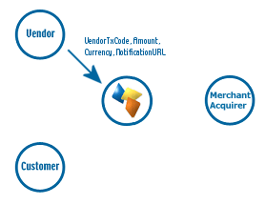
A script on the Vendor server builds and sends a secure POST (HTTPS) to the Protx server to register the transaction.

The script begins by generating a totally unique reference for this transaction. This must be different from ALL other transaction codes used by the Vendor’s system (even if it is for the same goods or same customer). It must also differ from codes used for refunds. This unique reference can be as simple as an incremental number, but many vendors use combinations of numbers, characters, date and time and so forth, to ensure the code is unique.

The POST must also include the Vendor Name, to identify them with the VSP, the total value of the purchase, the currency, a description of the goods, and optionally, the address of the script to which our server will send notification of authorisation success or failure (called the Notification URL, see step 2.7), and the address and postcode of the customer. For additional security, the Notification URL can be pre-registered to ensure the VSP only ever calls back to the vendor’s server.

If the vendor wishes to use Address Verification (AVS) and Card Verification Value (CVV2 or CV2) checks (please see additional protx documentation), the customer’s address, postcode and card CV2 value will also be submitted in this post.

HTTPS POSTs are encrypted messages, encoded using protx’s 128-bit Global certificate, and sent to port 443 on our web server. This document will not describe HTTPS posts in detail, but what is important to this discussion is that the vendor can be assured that no-one but Protx will be able to decrypt the message, and nothing Protx send back in the reply to that POST can be decoded by anyone except the vendor. Even if someone were to capture ALL the information sent in a 128-bit encrypted session, it would take all the computers in the world longer than the lifetime of the universe to break the encryption.

In the NT based kits (IIS, Domino and NT PERL) the HTTPS posting is handled by COM objects (Component Object Model, a Microsoft standard) that protx can provide to the vendor. This makes integration very simple. In Unix environments, protx recommend the use of open standards, like OpenSSL (see www.openssl.org), which can be installed on Unix variants to allow the server to make HTTPS posts (although you will require root privileges to install it). If your servers are hosted and maintained by a third party, you should check with them that you can install the COM objects or add UNIX system components. Many hosting companies now include OpenSSL as a standard on their UNIX servers.

2.3: VSP Server validates the POST and replies to the Vendor
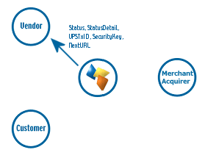
On receipt of the Vendor POST, the VSP begins by validating its contents. It first checks to ensure all the required fields are present, and that their format is correct. If any are not present or contain the wrong type of data, a reply with a Status of MALFORMED is generated, with the StatusDetail field containing a human readable error message. This normally only happens in the development stage.
If all fields are present and correct, the information in those fields is then validated. The Vendor name is checked against a pre-registered set of IP addresses, so VSP Server can ensure the POST came from a recognised source. The currency of the transaction is validated against those accepted by the Vendor. The VendorTXCode is checked to ensure it has not been used before. If any of the information does not check out, a reply with a Status of INVALID is sent back to the vendor, again with a human readable error message in StatusDetail.

If the Vendor receives either a MALFORMED or INVALID message, their server must communicate to the Customer that something is wrong and online purchases cannot be made at present. The vendor would normally then contact protx to resolve the error.

If everything in the original POST checks out, the transaction is registered with the VSP and a new transaction code is generated that is unique across ALL vendors using the VSP systems, not just unique to that specific vendor. This code, the VPSTxID, is sent back to the vendor in the reply along with a Status of OK and a blank StatusDetail field.

An OK message also contains a SecurityKey field. This is a ten character long alphanumeric string used as a key for confirming the MD5 hash signature in the notification post (see Step 2.7).

The Vendor must store the VPSTxID and SecurityKey against their own VendorTxCode in their database. This information is also, normally, associated with the shopping cart contents, so the Vendor server can retrieve all available order information easily.

The Vendor site then redirects the customer to PROTX (see next step).

2.4: Vendor redirects the Customer to the VSP
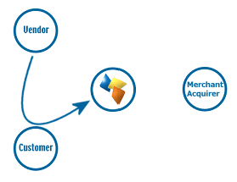
The reply sent back to the Vendor in Step 2.3 above contains a field called NextURL. This is the address of the VSP main page tailored to that specific transaction (i.e. it contains the VPSTxID as part of the URL).

Once the vendor has stored all relevant information, the script on their server generates a very simple HTML page that is sent to the customer’s browser and redirects them to the URL sent in the NextURL field.

This is the first stage at which anything noticeable has happened at the customer end. The HTTPS post and response described above are completely invisible to the customer. As far as the customer is concerned they clicked the “continue” button and now find themselves on the VSP Server payment page.

2.5: Customer accesses or enters card details on the VSP
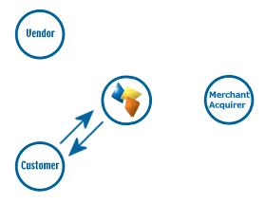
The customer is now on the VSP main page and can do one of three things:

- Enter a username and password to access their VSP card store and select a pre-registered payment card.
- Create a user account and e-wallet and use it to continue payment.
- Enter their card details on the system

The advantages of using the VSP card store are that card details only ever need to be entered once (when the wallet is created), and user-defined spending limits can be placed on each card, to prevent overspending or unauthorised use. If someone were to compromise the account by obtaining the username and password, they would not be able to view or change the credit card details, spending limits etc. if they did not know the answers to the security questions (akin to those used by the bank). If the spending limits are exceeded, the user is e-mailed and security alerts are raised at Protx. The accounts simply offer a degree of protection for the cardholder. Use of the wallet does not guarantee payment for the Vendor though, in fact they are never told if the payment has been made by a registered user or made via simple credit card entry.

The card details are verified by the VSP prior to communicating with the bank, to ensure the card LUHN check is passed, the card type matches the card number, the expiry date is not in the past and, where appropriate, the issue number and start date are in the correct format.

Once card details have been entered or selected, the user is presented with a confirmation screen, where they have one last chance to change their mind and cancel the transaction. If the user decides to cancel, the Vendor is sent a cancellation message at the notification stage and nothing is communicated to the banks. (Jump to Step 2.7)

If the user clicks to proceed, the VSP Server initiates the process of obtaining an authorisation code from the merchant acquirer.

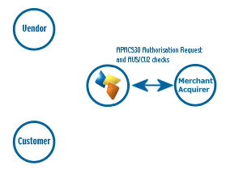
2.6: The VSP requests Authorisation from the Banks

The VSP Server sends an internal secure message from our front end processing systems to the back-end authorisation boxes, over our own private network.

The VSP authorisation services then format an APACS30 message and send the request to the Vendor’s merchant acquirer over the X25 banking network.

The request is normally answered within a second or so with either an authorisation code, or a failure message.

Whilst communicating with the merchant acquirer, the user is shown a page reading, “Authorising please wait…”

The VSP system treats all failures in the same way, replying to the Vendor with a NOTAUTHED message and a blank authorisation code.

If the acquirer does return an Auth code, VSP Server prepares an OK response for the vendor (next step)

If AVS and CV2 checks are being performed, the results are compared to the rule base set up for the vendor. If the bank has authorised the transaction but the card has failed the AVS and/or CV2 checks, protx immediately reverse the authorisation on the card and prepare a NOTAUTHED response for the vendor, returning the reason for the failure in the AVSCV2 field (next step).

2.7: VSP server contacts the Vendor on the Notification URL
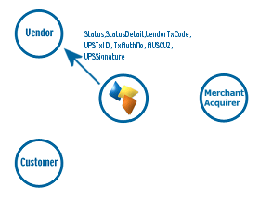
VSP server sends a HTTP Post to a script on the Vendor’s server to indicate the outcome of the transaction.

This POST contains a Status field that holds either “OK”, if the transaction was authorised at stage 2.6, “NOTAUTHED”, if the authorisation failed, or “ABORT” if the user decided to cancel the transaction whilst on the protx site. (There is actually a 4th condition, “ERROR”, but that only occurs when something serious has occurred at Protx, for example database failure, or all X25 links down)

The script POSTed to is that passed in stage 2.2 (the NotificationURL in the original HTTPS post), or the pre-registered address held in the protx database.

It is up to the Vendor to decide how to handle each type of message, but in each case VSP Server expects a reply of some description (see step 2.8).

This POST is NOT over HTTPS, just HTTP, which means it is plain text and not encrypted. The reason for this is to allow vendors to operate simple web sites that are not secured with certificates if they so choose (certificates can take a few weeks to order, and cost about £400 per year for 128-bit keys). Because of this, a clever hacker could intercept the packets of information, modify the response before sending it on to the Vendor. They could, for example, change a NOTAUTHED message to an OK message. To counteract this, the message has a VSPSignature field attached to sign the POST.

If the Status is OK, the Vendor script should read the VendorTxCode and VPSTxID from the POST and retrieve the relevant information about the order from their database (most importantly the SecurityKey for this transaction, that was passed back in stage 2.3.)

Using the security key, and other information in the POST, the script then reconstructs the message and runs it through an MD5 Hash algorithm. Hash algorithms are one-way functions (that is, if you pass the same data through the same algorithm you’ll get the same signature value every time you run it. There is, however, no way to regenerate the original data from the signature data, even if you know the algorithm used and the key). Hashing is often used to digitally sign messages.

The script then compares the value it generated from its own MD5 hashing to the VSPSignature value in the POST. If they match, the message has not been tampered with. If they do not, then it may well have been altered and the vendor must act accordingly by declining the transaction and notifying us immediately!

If the Hash values match, the Vendor should store the TxAuthNo field in their database alongside the VendorTxCode and VPSTxID. In the event of a chargeback, the reference number for the transaction provided by the bank is that sent in the TxAuthNo field (we call it the VPSAuthCode). The TxAuthNo field DOES NOT contain the actual AuthCode sent by the bank, because it is not unique.

As mentioned above, the Vendor MUST reply to the post in all circumstances (see next step), otherwise the transaction monitor will keep trying to notify the vendor about the success or failure of the transaction (see section 3).

If the VSP cannot contact the notification URL, it tries a further 9 times, at approximately 2-second intervals with REPEATED suffixed to the STATUS, in case the Vendor server is busy. If the Vendor’s server still cannot be contacted, the transaction is timed out by the Transaction Monitor (see section 3)

The notification script should handle all message types (OK, NOTAUTHED, ABORT and ERROR). protx provide an example of this script in the kits which will require modification by the vendor to talk to their database or performs actions specific to their application.

2.8: The Vendor replies to the VSP Notification POST
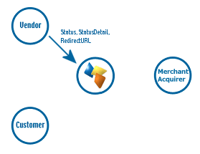
The Vendor script replies to the VSP POST with three fields. Status, which indicates if they wish to accept the transaction notification, StatusDetail to hold human readable reasons if they do not, and RedirectURL, which is the completion page to which the user should be sent.

The Vendor can reply with a status of either OK, INVALID or ERROR. ERROR is very rarely used, and should ONLY be sent by the vendor if something serious has happened with their server or database.
INVALID should be sent if the vendor is not happy with the contents of the POST, either because the MD5 hash signatures did not match, or they were unable to find the referenced transaction in their database.
OK is sent if the vendor is happy with the notification and wishes to proceed.

Regardless of status, the RedirectURL must contain a valid URL to the final completion page on the Vendor’s site. When the Status is OK, this is normally a page saying “Thank you for your order, reference 123456, please come again.” In the case of INVALID or ERROR, the RedirectURL will normally point to an error page, often with a support telephone number.

If the Status sent back by the Vendor is anything other than OK then the transaction is never settled with the bank (see Step 2.10) and the customer is NOT charged for the goods or services. The vendor, obviously, should not send goods out to the customer.

2.9: VSP redirects the Customer back to the Vendor site

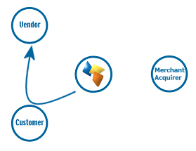
The VSP server sends a simple HTML page to the user’s browser that redirects them to the page referenced in the RedirectURL field sent in step 2.8.

As before, the customer is unaware of the background POST and response process in the previous two steps. From their perspective they simply clicked “Proceed”, got a message saying “Authorising please wait…” and then found themselves back on the original Vendor website on a completion page of some description.

The real time processing of the transaction by Protx is now complete.

2.10: VSP sends daily Batch file to initiate payments
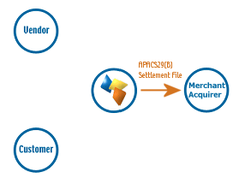
Once per day, at 2:10am, the VSP system takes all authorised transactions for each acquirer and creates an APACS29(B) format batch file.

Transactions for ALL vendors who use the same merchant acquirer are included in this file i.e. it is not vendor specific.

The file is uploaded over File Transfer Protocol (FTP) via either an ISDN or PSTN connection with the bank.

If the file does not transmit correctly, the system tries a further nine times at 10-minute intervals. If all 10 attempts fail, the transactions for that bank are released and included in the following day’s batch instead. protx monitor each day to ensure the file has been sent, and if not, the service department correct the problem during the day to ensure the file is sent correctly that evening.

The acquirers send summary information back to protx to confirm receipt of the file, but in many cases protx have to wait for the acquirers to send paper confirmation through the post to check that the file was accepted and no transactions were rejected.

3: The VSP Transaction Monitor

If the VSP Server system is unable to notify the Vendor’s site of success or failure (see step 2.7), even after 10 attempts, then the transaction is placed in suspension.

Likewise, if a customer reaches the protx page, changes their mind but does not click Cancel, choosing instead to simply close their browser, or go elsewhere, then the transaction is stuck in limbo.

Protx guarantee to inform the Vendors about the success or failure of every transaction sent to the system, so transactions such as those mentioned above have to be dealt with.
The VSP transaction monitor is a service that runs within the secure private network, monitoring the database, looking for transactions that are over 15 minutes old. When it finds one, it changes the status to CANCELLED and sends an “ABORT” post to the Vendor at the specified notification URL (in exactly the same manner as in Step 2.7).

Because the process is identical to a normal notification post, the Vendor script should reply as in step 2.8 with a Status and a RedirectURL. Because the user is no longer online, no redirection message is sent to the client browser, but the VSP can work on the principle that if it gets a reply from the Vendor site, their servers are aware that the transaction has been cancelled, so goods will not be shipped and the user will not be charged.

If the Vendor does not reply to the post, the service tries another 10 times at 2-minute intervals; then 10 times at 1-hour intervals; then 10 times at 1-day intervals and finally 6 times at one-month intervals. If the vendor site still cannot be contacted after that time, the VSP monitor stops trying.

4: Other VSP Server Messages

The steps described in the above sections explain the process of registering a new payment transaction with the VSP Server. This section outlines the other types of message that can be sent from the Vendor server to protx, to accomplish additional payment related tasks.

4.1:PREAUTH requests

PREAUTH requests are made in exactly the same manner as normal payments (steps 2.1 to 2.9 above). PREAUTHs, however, do not move any money from the customer account to the online merchant. This request merely validates the card, checks that it has sufficient funds to support the transaction, obtains an auth code, and then immediately reverses the transaction so that the customer is not left with an outstanding shadow on their card.

This transaction type is very useful for merchants who wish to create online accounts. The user’s card can be validated but not charged when the account is set up, then charged for goods and services at a later date using the REPEAT payment request (see 4.4 below) without the need for the customer to re-enter their card details.

4.2: DEFERRED payments

DEFERRED payments are registered in exactly the same manner as normal payments (see stages 2.1 to 2.9). The only difference is that deferred payments are not automatically settled that evening (step 2.10) but are instead held in a queue until a message is received from the vendor server releasing the payment (see step 4.3).

Deferred payments are useful in situations where the online merchant wishes to validate the customer’s card but does not wish the funds to be committed until the goods are shipped.

NOTE: When a card is authorised a shadow is placed on the cardholder’s account. This marks the payment against the account and prevents the user from spending that money before the settlement file is received. This shadow is always valid for 24 hours, but for some cards cannot be guaranteed after that. If the shadow has expired and the settlement file received, the money will still be transferred if sufficient funds exist. If they do not, however, the authorisation is rejected. Merchants who wish to use deferred payments should bear this risk in mind. protx recommend using a PREAUTH (see above) to validate the card, then a REPEAT payment (see 4.4) when the goods are about to be shipped. If the REPEAT payment fails the goods can be held back until the customer is contacted.

4.3: RELEASE deferred payment
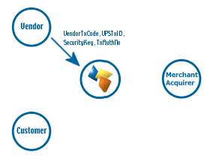
DEFERRED payments (see 4.2) and REPEATDEFERRED payments (see 4.5) are not settled (and hence funds are not transferred) until a RELEASE message is received. The release message is a server-to-server HTTPS POST containing the transaction type “RELEASE” and the VendorTxCode, VPSTxID, SecurityKey and TxAuthNo of the original deferred payment.

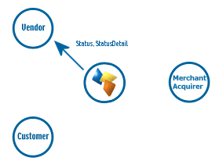
The VSP Server replies to the Release message with a Status and StatusDetail field giving the outcome. A status of “OK” indicates a successful release of a deferred payment. The referenced transaction will be included in the daily batch file sent the following morning.

“INVALID” will be returned if the referenced transaction is already released, or not a deferred payment in the first place.

“MALFORMED” is normally only returned during development and indicates the release request was poorly formatted. “ERROR” is reserved for problems within protx itself.

4.4: REPEAT payments

REPEAT payments are a convenient means of charging additional amounts to a customer who has already made payments on a merchant’s site, without the need to request the customer’s card details again. The card details are already known by the VSP system through reference to the previous transaction.

The original transaction can be ANY type of VSP Server transaction (i.e. a PAYMENT, a DEFERRED payment, PREAUTH or even a previous REPEAT payment) as long as it was authorised. The REPEAT request does not actually repeat the original transaction; it merely makes a further request for payment against whichever card was used to perform the original transaction. So, for example, a common use of the repeat payment is for vendors to PREAUTH the card when the user creates an account, then request a REPEAT payment against the initial PREAUTH when they actually wish to charge for something.

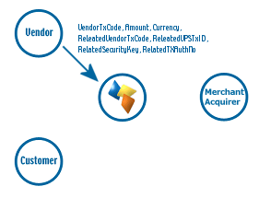
To make a repeat payment, the vendor needs to supply the VendorTxCode, VPSTxID, SecurityKey and TxAuthNo from the original transaction, along with the repeat payment information (i.e. the amount, currency, and VendorTxCode for this new transaction) in a server-to-server HTTPS POST

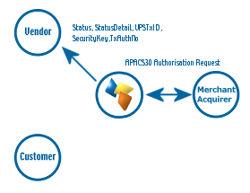
A new transaction is created by VSP Server, the card details from the original transaction extracted and the card charged with the amount specified.

If the transaction is successful a new TxAuthNo is returned, along with a VPSTxID and a SecurityKey. These should be stored by the vendor alongside the VendorTxCode for this transaction so that this too can be REPEATED if desired, or REFUNDED if necessary (see 4.6)

The Status and Status detail fields, as always, contain human readable error information in the event of a failure.

AVS and CV2 information is not checked for a repeat payment, since it is assumed that such checks must have been passed in the original payment for a TxAuthNo to have been returned, so additional checks are surplus to requirement.

4.5: REPEATDEFERRED payments

A REPEATDEFERRED payment is exactly the same as a repeat payment except (like a DEFERRED payment, see 4.2) the funds are not committed immediately. Instead the transaction is held in a queue waiting to be settled until a RELEASE message is received (see 4.3). Like normal REPEAT payments, the original transaction referenced in this request does not have to be an earlier REPEATDEFERRED request, but can be any authorised transaction (be it PREAUTH, PAYMENT, DEFERRED etc.)

4.6: REFUND requests

To request a refund the vendor must supply the unique reference codes and auth code of the original successful payment, along with the amount to refund. The original transaction can be either a standard PAYMENT, or a DEFERRED payment that has already been RELEASED, or a REPEAT or released REPEATDEFERRED payment. The refund method is identical irrespective of the payment type.

A vendor can make any number of refunds against an original purchase transaction as long as the total amount refunded does not exceed the amount of the original payment.
To make a refund, the vendor needs to supply the VendorTxCode, VPSTxID, SecurityKey and TxAuthNo from the original transaction, along with the refund information (i.e. the amount, currency, and VendorTxCode for this refund) in a server-to-server HTTPS POST

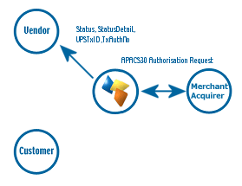
A new transaction is created by VSP Server, the card details from the original transaction extracted and the card refunded with the amount specified.

If the refund is successful a new TxAuthNo is returned, along with the VPSTxID of this new transaction.

The Status and Status detail fields, as always, contain human readable error information in the event of a failure.

